After click on connect wallet  
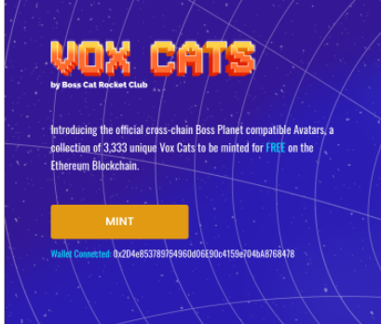  
  
Wallet Connected: 0x2D4e853789754960d06E90c4159e704bA8768478  
  
after click on mint  
  
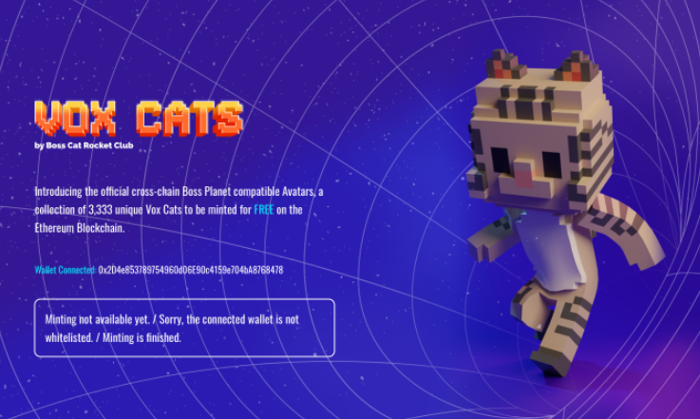  
Minting not available yet. / Sorry, the connected wallet is not whitelisted. / Minting is finished.

after click on the mint button this modal will open  
  
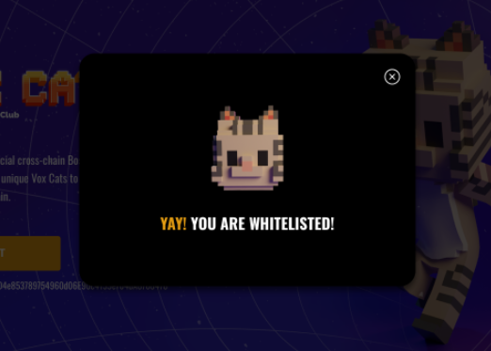

YAY! YOU ARE WHITELISTED!  
  
  
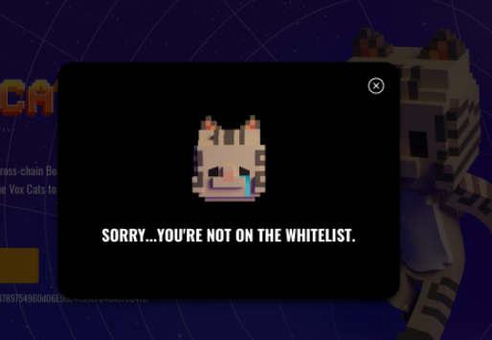

SORRY...YOU'RE NOT ON THE WHITELIST.  
  
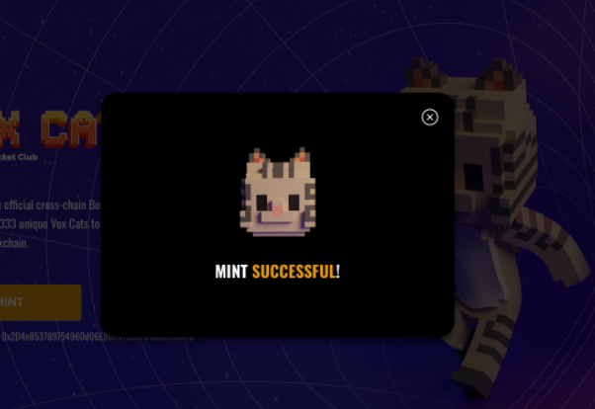  
  
MINT SUCCESSFUL!  
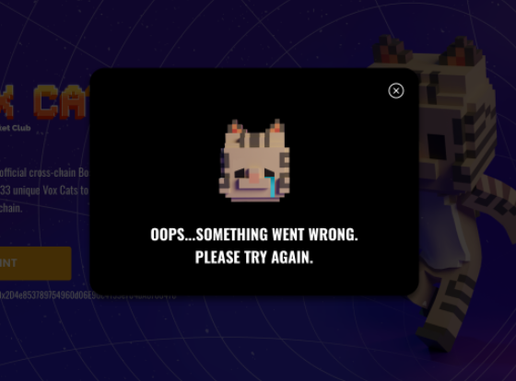  
  
OOPS...SOMETHING WENT WRONG. PLEASE TRY AGAIN.